EXPT NO:3 | CLEANSE DATA BY HANDLING MISSING VALUES, OUTLIERS, AND INCONSISTENCIES USING TABLEAU AND POWERBI
DATE: 10.07.2026

PRE-LAB QUESTIONS (PROVIDE BRIEF ANSWERS TO THE FOLLOWING QUESTIONS)

- What are the potential impacts of missing values in a dataset, and what are some common strategies to address them in Tableau and Power BI?

Missing values in fields such as Sales, Profit, Region, Category, or Order Date can lead to inaccurate calculations, incomplete visualizations, and incorrect analysis. In Tableau, missing values can be handled using Data Interpreter, filters, and calculated fields such as IFNULL(). In Power BI, Power Query can be used to identify null values and replace them with suitable values such as 0, the mean/median, or "Unknown", depending on the field.

- What is the importance of identifying and addressing outliers in a dataset? How can outliers affect data analysis and model performance?

In the Superstore dataset, extremely high Sales or Profit values may be potential outliers. Identifying outliers is important because they can significantly affect averages, trends, and statistical analysis, giving a misleading representation of overall business performance. Outliers can also negatively affect machine learning models by influencing model parameters and reducing prediction accuracy.

- What types of data inconsistencies might you encounter during data cleansing, and how can Tableau and Power BI help in resolving them?

In a Superstore dataset, inconsistencies may occur in Region, Category, Product names, and Order Date fields. Examples include different spellings or capitalization of the same region, inconsistent category names, duplicate records, incorrect data types, and different date formats. Tableau provides features such as Group, Alias, filters, and data type conversion, while Power BI provides Power Query, Replace Values, Remove Duplicates, and Change Data Type to standardize and correct these inconsistencies.

- How do you identify patterns in data using visualizations to spot missing values, outliers, and inconsistencies?

Visualizations help identify unusual patterns and data quality issues in the Superstore dataset. Bar charts can reveal missing or inconsistent Region and Category values, while histograms and box plots can highlight unusual Sales and Profit values that may be outliers. Line charts can help identify gaps or unusual patterns in Order Date data, and scatter plots can show unusual relationships between Sales and Profit.

- What is the role of calculated fields in data cleansing, and how can they be used to handle missing values and outliers in Tableau/Power BI?

Calculated fields help create new values based on existing data and are useful for handling missing values and identifying outliers. In Tableau, IFNULL([Sales], 0) can replace missing Sales values, while an expression can flag unusually high Sales as potential outliers. In Power BI, DAX calculated columns using IF() or ISBLANK() can replace or identify missing values, while conditional expressions can classify Sales or Profit values as "Normal" or "Potential Outlier" for further review.

IN-LAB EXERCISE:
OBJECTIVE:
To clean a given dataset (e.g., Superstore Sample in Tableau and Financials/Sales Data in Power BI) by identifying and resolving missing values, outliers, and inconsistencies using built-in tools, ensuring the dataset is accurate and ready for analysis.

PROCEDURE:

Open the Tool and Connect Dataset
    - Open Tableau Desktop , Power BI Desktop.
    - Load the built-in dataset (Sample - Superstore in Tableau / Financials in Power BI).
    - Preview the dataset to understand its structure.

Initial Inspection
    - Explore fields such as Sales, Profit, Region, or Product Category.
    - Check for nulls, inconsistent text values (e.g., "South Region" vs. "South"), or date formatting issues.

Handling Missing Values
    - Use Data Interpreter (Tableau) / Power Query (Power BI) to highlight nulls.
    - Replace missing numerical values with mean/median, and text with "Unknown".
    - Use calculated fields: IFNULL([Field], Default) in Tableau or IF(ISBLANK([Field]), "Unknown", [Field]) in Power BI.

Detecting and Managing Outliers
    - Create scatter or box plots for Sales and Profit to identify extreme values.
    - Choose strategies:
      - Filter them temporarily.
      - Apply caps using calculated columns.

      - Flag them with labels for review.

Resolving Inconsistencies
    - Use Group/Alias (Tableau) / Replace Values (Power BI) to standardize text.
    - Normalize data formats, such as date fields or currency units.

Validation with Visuals
    - Build dashboards with histograms, bar charts, and box plots to visually confirm improvements.
    - Compare before/after cleaning stages for accuracy.

Save the Cleaned Dataset
    - Save as .twbx (Tableau) / .pbix (Power BI).
    - Optionally export cleaned data to .csv.

Summary Dashboard
    - Create a visual summary of the cleaning process, highlighting:
      - Fields corrected.
      - Nulls/outliers removed or adjusted.
      - Clean dataset metrics (record count, completeness %).

Experiment Dataset:
- Tableau: Sample - Superstore
- Power BI: Financials or Sales Data

How to Access:
Tableau:
  - Navigate to: Start Page → Sample Workbooks
  - Or: Help → Sample Data → Open Sample Data Folder

Power BI:
  - Navigate to: Home → Get Data → Excel → Choose sample datasets (e.g., Financial Sample.xlsx)
  - Microsoft also hosts Power BI sample datasets online.

Fields Used:
- Sales
- Profit
- Region
- Category
- Order Date / Transaction Date

Power BI:
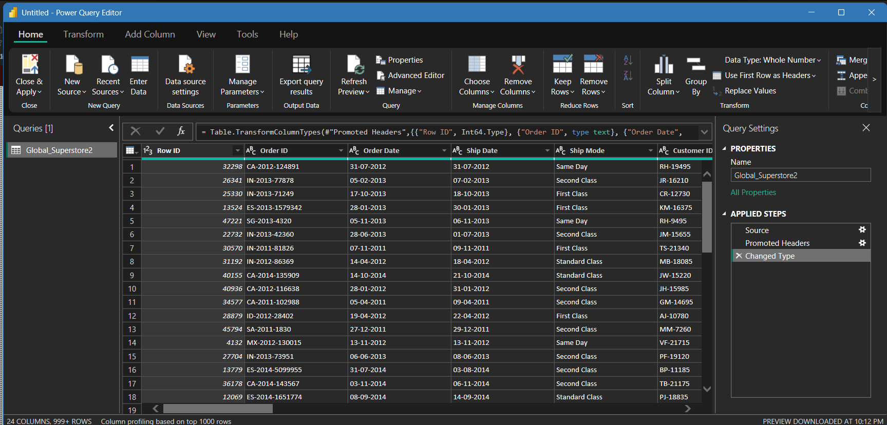

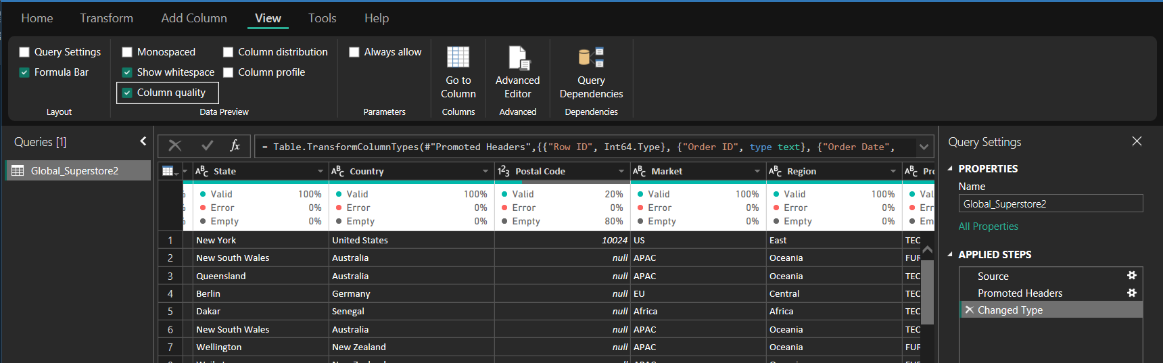

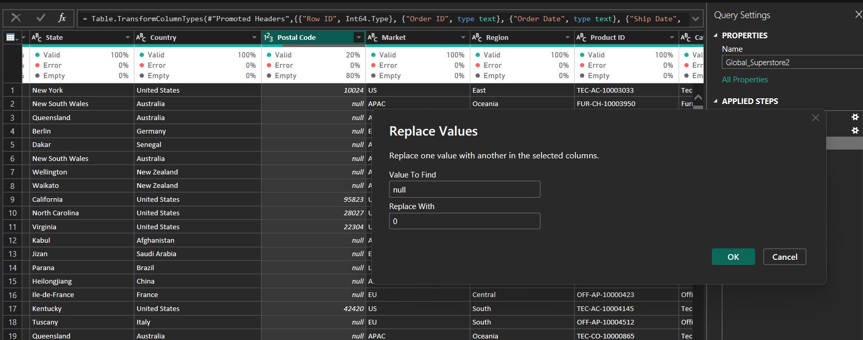

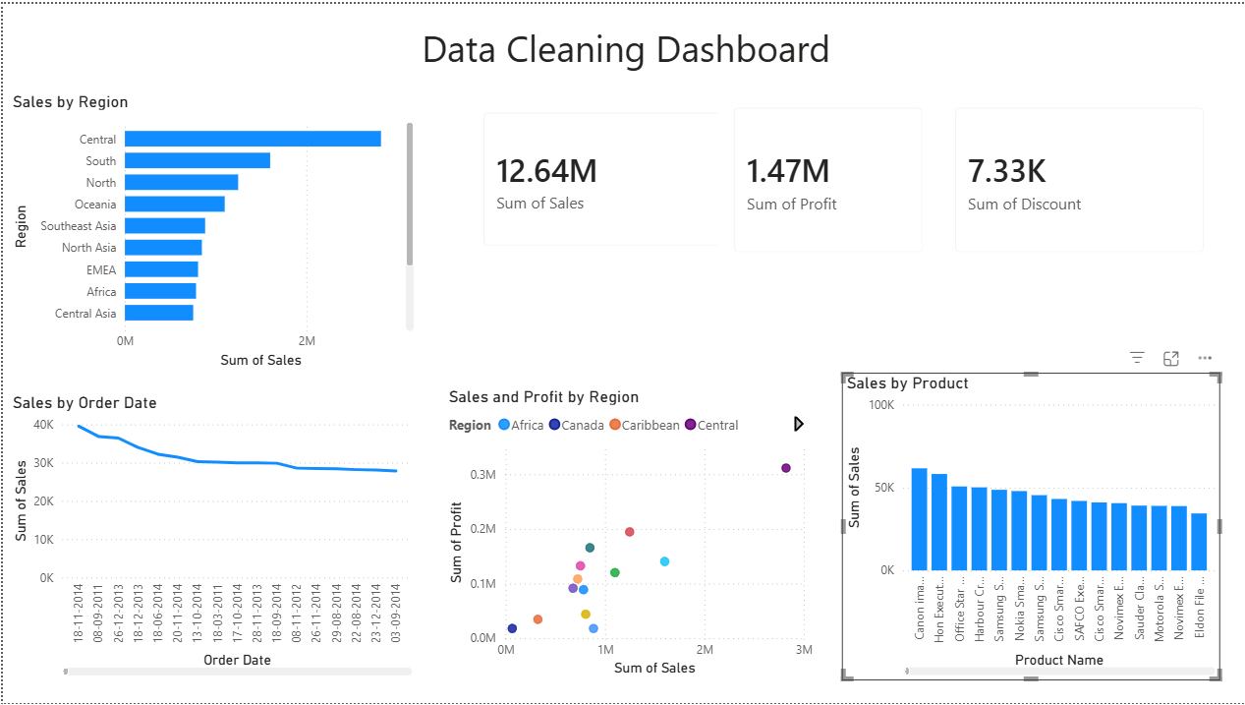

Tableau:

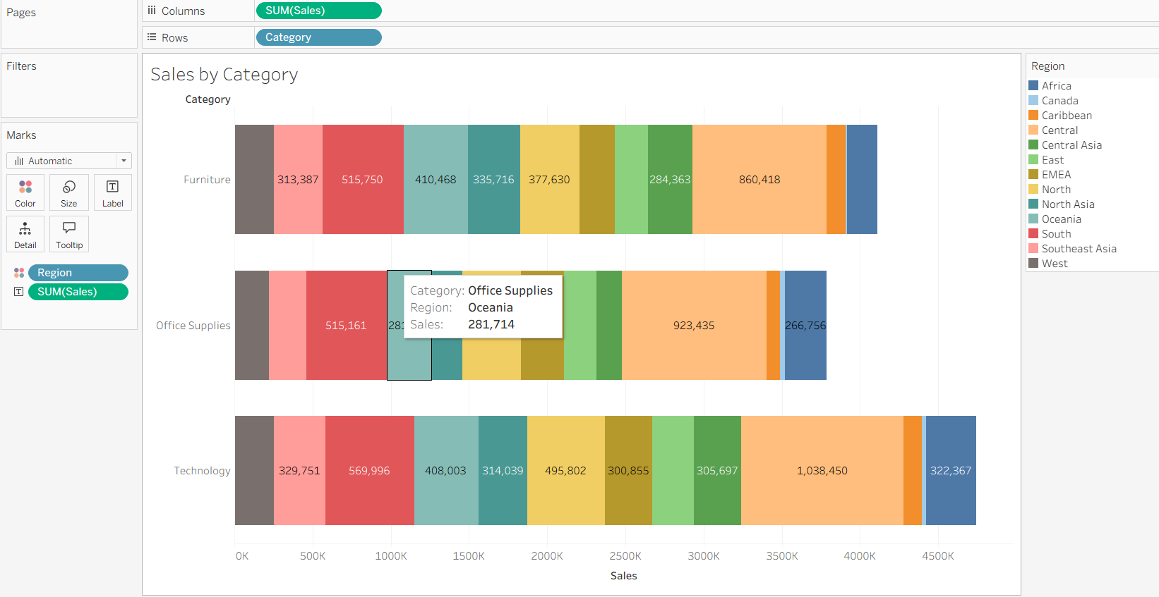
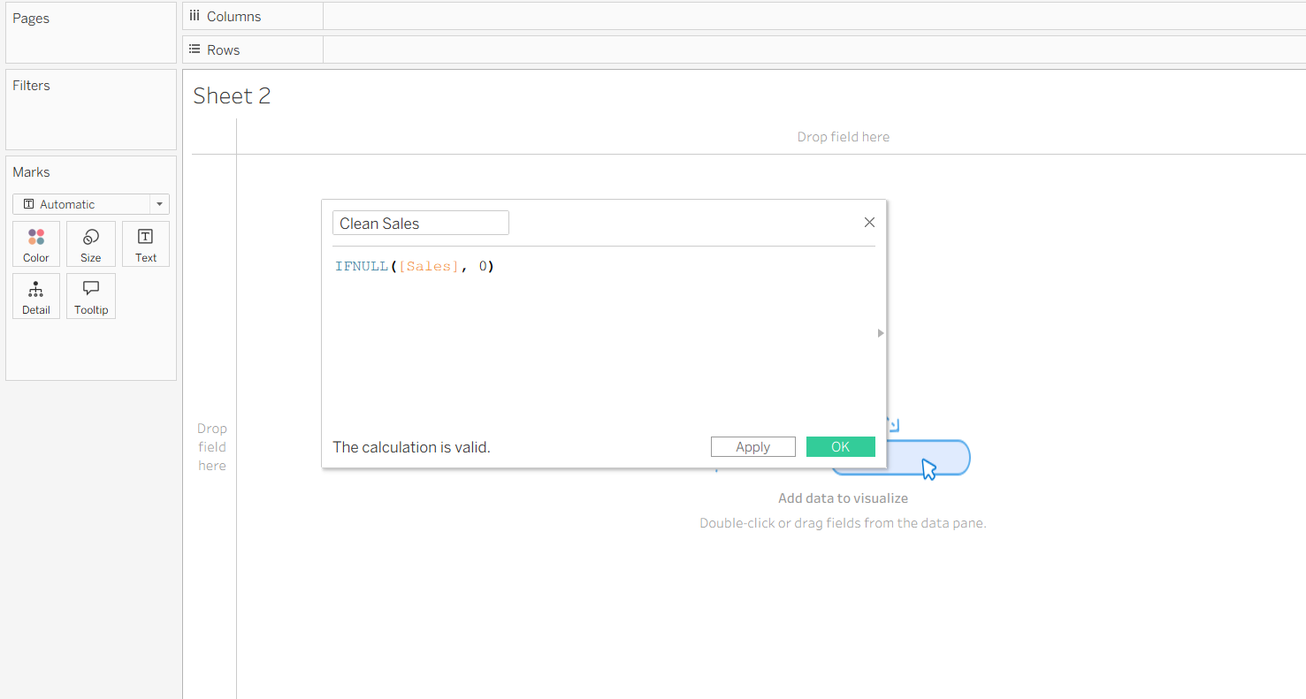

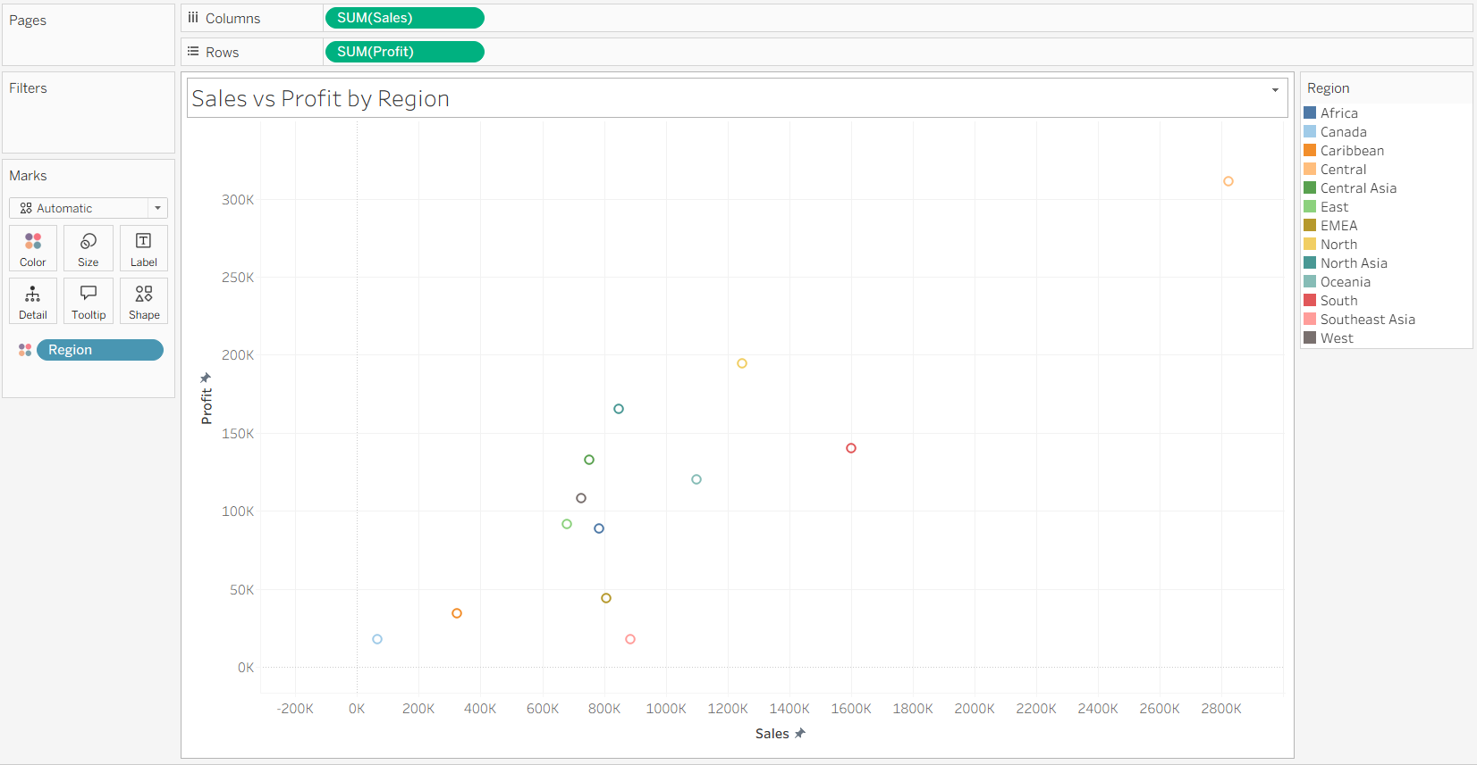

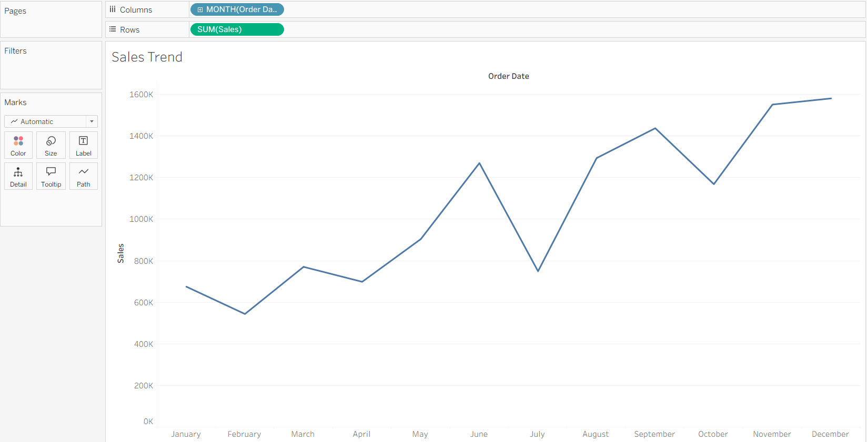

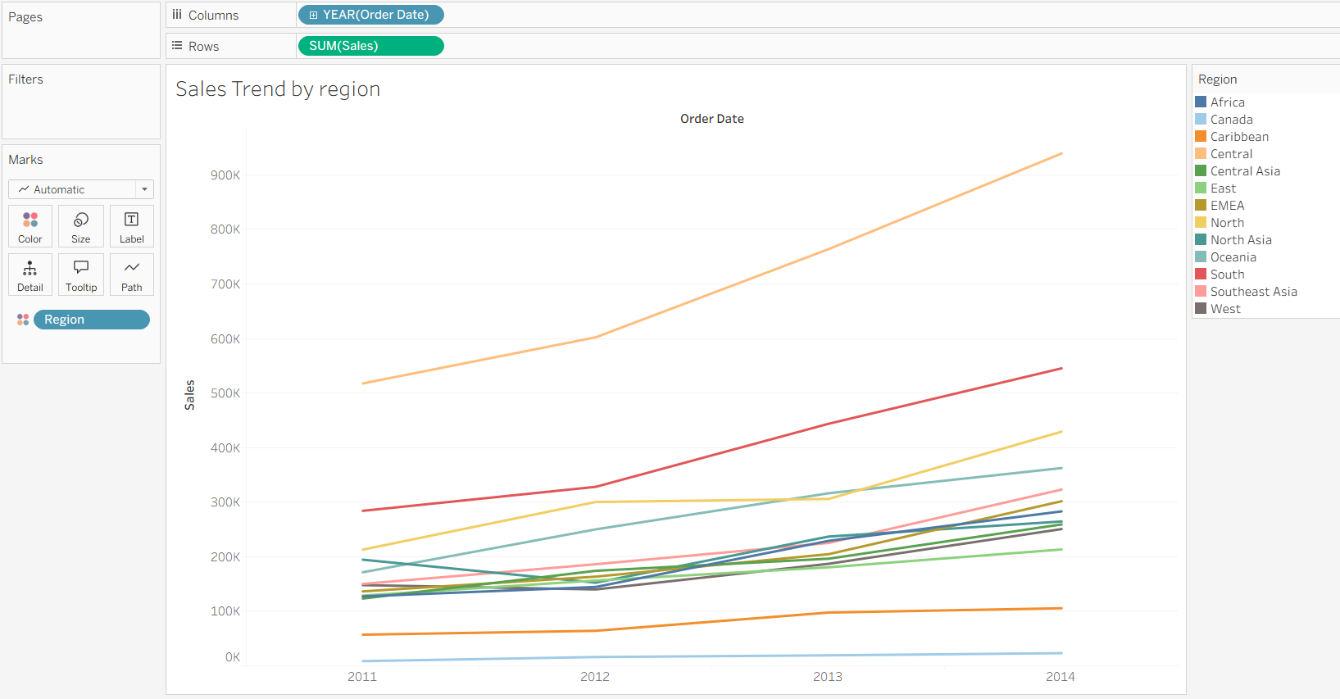

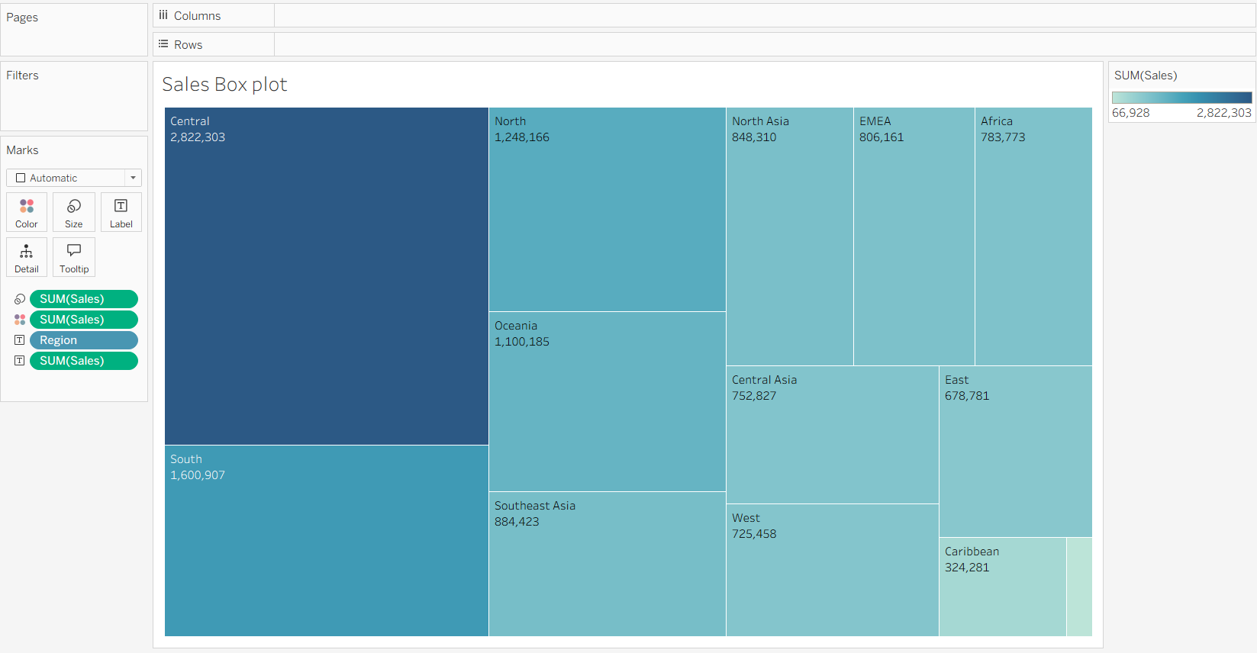

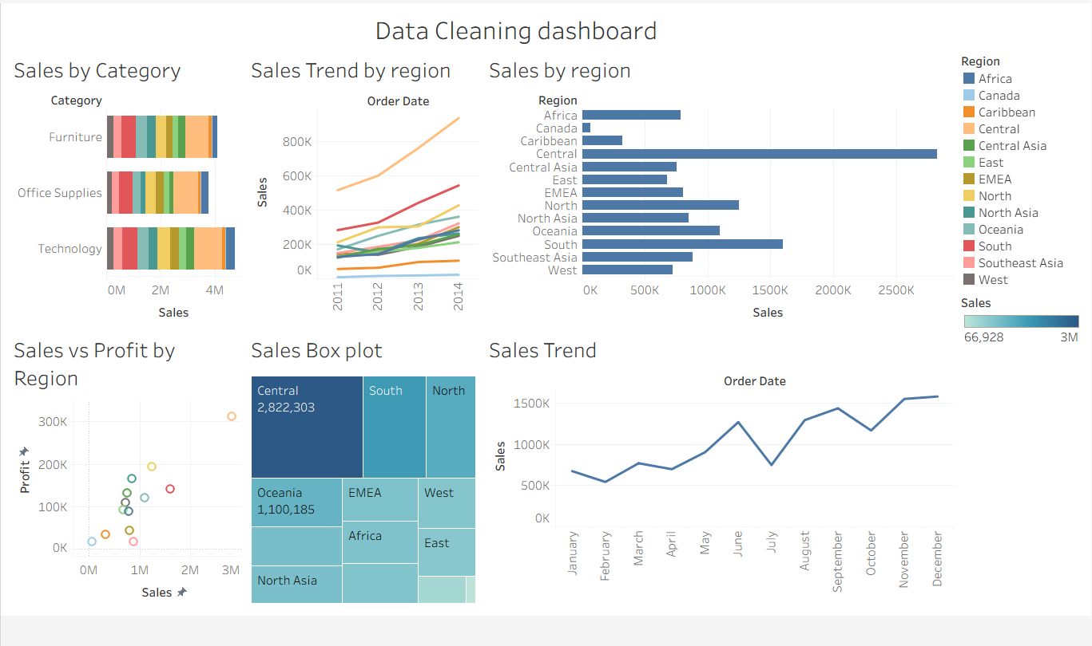

POST-LAB QUESTIONS (PROVIDE BRIEF ANSWERS TO THE FOLLOWING QUESTIONS)
- What method did you use to replace missing values in numeric fields?
Missing values in numeric fields such as Sales and Profit were identified using the data-cleaning tools in Tableau/Power BI. Where required, missing numeric values were replaced using an appropriate statistical value such as the mean or median, while values that represented no sales or profit were replaced with 0. This ensured that missing values did not affect calculations and visualizations.

- How were outliers handled in your dataset and what visual confirmed their correction?
Potential outliers in Sales and Profit were identified using scatter plots and box plots. The extreme values were reviewed and either filtered, flagged for further investigation, or retained when they represented valid transactions. The box plot was used to confirm the distribution of the data and verify that the identified extreme values were properly handled.

- What inconsistencies were detected in categorical values and how were they standardized?

Inconsistencies were checked in categorical fields such as Region and Category, including differences in capitalization, spelling, or naming formats. In Tableau, Group and Alias features were used to standardize values, while in Power BI, Power Query's Replace Values option was used. After standardization, similar values were represented using a single consistent name.

- Describe how calculated fields helped in resolving data issues.
Calculated fields helped create cleaned and categorized values without modifying the original dataset directly. For example, missing numeric values could be replaced using IFNULL() in Tableau or ISBLANK() with IF() in Power BI. Calculated fields were also used to flag potential outliers, classify records as Normal or Potential Outlier, and support the validation of cleaned data.

- How did your dashboard demonstrate the effectiveness of the data cleaning process?

The dashboard demonstrated the effectiveness of data cleaning by presenting visualizations such as Sales by Region, Sales by Category, Sales Trends, Profit vs. Sales, and Box Plots. These visuals helped confirm that missing values were handled, categorical values were standardized, and potential outliers were reviewed. The dashboard also provided key metrics such as record count, total Sales, total Profit, and data completeness, allowing the cleaned dataset to be compared and validated for accurate analysis.

RESULT:

The dataset was successfully cleaned and prepared for accurate analysis using Tableau and Power BI. Issues such as nulls, inconsistencies, and outliers were identified and resolved, improving data quality significantly.

ASSESSMENT

Description | Max Marks | Marks Awarded
Pre Lab Exercise | 5
In Lab Exercise | 10
Post Lab Exercise | 5
Viva | 10
Total | 30
Faculty Signature

